Pre-K Supply List

o 1 backpack (Large size to fit folders/projects)
o A reusable water bottle filled with water each day
o 2 Primary Composition Books
o 2 Elmer’s glue sticks
o 1 package of baby wipes
o 2 packages of Clorox wipes
o 4 rolls of paper towels
o 3 boxes of tissues
o 2 bottles of hand soap
o 2 bottles of hand sanitizer
o 1 box of gallon size Ziploc bags
o 1 box of quart size Ziploc bags
o 1 package of white copy paper
o 1 nap mat with pillow attached, see picture below (can be found on Amazon)

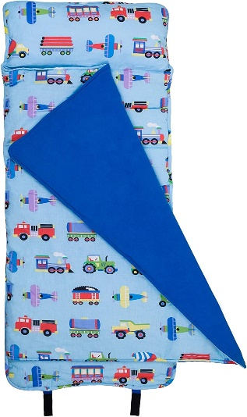

o 1 picture of your child with their family
o 2 complete changes of clothes to be kept in school (shorts & t-shirt for beginning of the year and long sleeves & pants for when it gets cooler)
**Please label everything with your child’s first and last name**

