3K Supply List
o 1 backpack (Large size to fit projects)
o A labeled reusable water bottle filled with water each day
o 2 Primary Composition Books
o 2 extra-large Elmer’s glue sticks
o 1 package of baby wipes
o 2 containers of Clorox wipes
o 1 box of Band-Aids
o 3 rolls of paper towels
o 2 boxes of tissues
o 3 bottles of hand soap
o 2 bottles of hand sanitizer
o 1 package of 5 oz. plastic cups
o 1 box of gallon size Ziploc bags
o 1 box of quart size Ziploc bags
o 1 package of white copy paper
o 1 package Expo Dry Erase Markers (assorted colors)
o 1 package of Sharpie Permanent Markers (assorted colors)
o 1 nap mat with pillow attached, see picture below (can be found on Amazon)
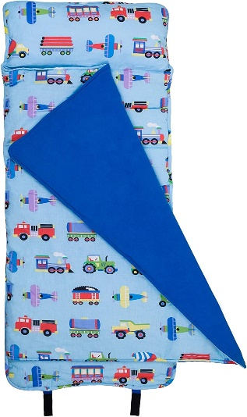
o 1 picture of your child with their family
o Black velcro
o 1 Stamp pad
o Kinetic sand
o 1 plastic only red folder for communication
o 3 photos of your child’s face (up close)
o 2 complete changes of clothes to be kept in school (shorts & t-shirt for beginning of the year and long sleeves & pants for when it gets cooler)
o Pull-ups only if your child uses them

**Please label everything with your child’s first and last name**

***The nap Mat will be sent home to be washed each Friday, please send back each Monday.***

We will ask for supplies to be renewed throughout the year, especially paper towels and soap, as it gets used up.

